SECTION | MARKS
A
B
TOTAL
TRINITY PRIMARY SCHOOL – BUKOTO
REVISION WORK
CLASS : P.4
LEARNING AREA: LITERACY
Name: _______________________________________________
Date: _________________________________________________
SECTION A
- Name the main natural source of light in the environment.
__________________________________________________
- What is the importance of a sign post to a school?
__________________________________________________
- In which one way are houseflies dangerous to people?
__________________________________________________
- Name the sense organ for smelling.
__________________________________________________
- Identify the physical feature shown below.
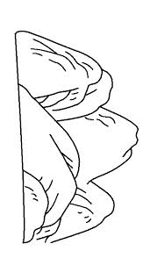___________________________________________
- Give one reason why first aid is given to casualties.
__________________________________________________
- How do people manage the rainy weather?
__________________________________________________
- Name the type of soil used for making pots.
__________________________________________________

- How are policemen useful in our division?
__________________________________________________
- Give one reason why plants with weak stems climb others.
__________________________________________________
- Which property of air is shown in the diagram below.
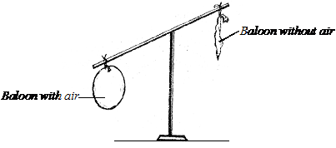____________________________
- State the fastest type of transport.
__________________________________________________
- Mention one way how bees protect themselves.
__________________________________________________
- Name one basic need of people.
__________________________________________________
- Write down one reason why people brush their teeth after every meal.
__________________________________________________
- State one place where people can get clay soil.
__________________________________________________
- Give one way how a broom is useful in a home.
__________________________________________________
- Who was the first Muganda?
__________________________________________________
- State one way of preventing germs from our body.
__________________________________________________
- What is the use of a title on a map?
__________________________________________________

- Name the part of a bird marked X.
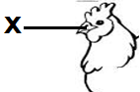_____________________________________________
- State one play material made from banana fibers.
__________________________________________________
- Name one group of people who prepare food at school.
__________________________________________________
- Mention one way of keeping our body clean.
__________________________________________________
- Name one common tribe in your community.
__________________________________________________
- Mention the use of a first aid box to people.
__________________________________________________
- State one way of saving electricity at home.
__________________________________________________
- Give the use of spioracles to an insect.
__________________________________________________
- Apart from breast feeding, give one other role of a mother at home.
__________________________________________________
- An aeroplane flies in air, why is it not called a living thing?
__________________________________________________
- What is the importance of a dentist in our community?
__________________________________________________
- Draw and name any one item used in keeping our body clean.

- Name one activity done by people around lakes.
__________________________________________________
- What is the use of a saucepan at home?
__________________________________________________
- Give one use of leaves to plants.
__________________________________________________
- Name the road sign drawn below.
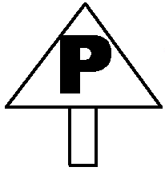______________________________________
- State one method used to preserve fish.
__________________________________________________
- Give any one immunisable disease you know.
__________________________________________________
- Why do animals move from one place to another?
__________________________________________________
- What do we call stories of long ago?
__________________________________________________

SECTION B
- (a) Name any two components of air.
- __________________________________________________
- __________________________________________________
(b) Which component of air supports burning?
__________________________________________________
(c) Identify any one property of air.
__________________________________________________
- (a) Give one example of a school symbol.
__________________________________________________
(b) State two important groups of people in our school.
(i) __________________________________________________
(ii) __________________________________________________
(c) Mention one use of symbols to a school.
__________________________________________________
- (a) State two responsibilities of a father at home.
- __________________________________________________
- __________________________________________________
(b) Give any one member of a nuclear family.
__________________________________________________
(c) Identify one activity done by a child at home.
__________________________________________________
- Match the following animals with their products.
LIST A LIST B
- pigs eggs
- rabbits mutton
- hen fur
- sheep pork
- pigs________________________
- rabbits________________________
- hen________________________
- sheep________________________
- Below is a lifecycle of a housefly. Use it answer the questions that follow.
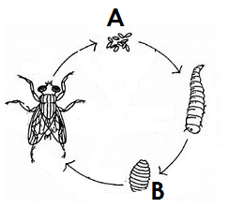
- Name the stages marked.
- A________________________
- B________________________

- State two diseases spread by a housefly.
- ________________________
- ________________________
- (a) Give two examples of people who keep peace and security in a community.
- ________________________________________________
- ________________________________________________
(b) State two ways a P.3 child can promote peace and security at school.
(i) ________________________________________________
(ii) ________________________________________________
- (a)What is wind?
________________________________________________
(b) Give two uses of wind to people.
(i) ________________________________________________
(ii) ________________________________________________
- Write down one danger of wind.
________________________________________________
- (a) Name any two types of clouds.
- __________________________________________________
- __________________________________________________
(b) Name the type of clouds that give us rainfall.
__________________________________________________
(c) Mention one process that helps in rain formation (clouds).
__________________________________________________
- (a) What is seed germination?
__________________________________________________
(b) Name any two conditions needed for seed germination.
(i) __________________________________________________
(ii) __________________________________________________
(c) Give any one type of germination.
__________________________________________________
- (a) State any two materials used to construct a permanent house.
- __________________________________________________
- __________________________________________________
(b) _________________________ is a place where people cook food from at home.
(c) Give one example of a house common in your community.
__________________________________________________
- Below is a diagram of a fish. Use it to answer the questions.
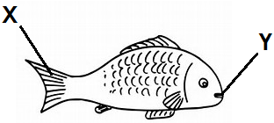
- Name the parts labeled X and Y.
X _________________________
Y _________________________
- Give the habitat of the above animal.
__________________________________________________
- Which class of food do we get from eating fish?
__________________________________________________
- (a) Write down two uses of domestic animals to people.
- __________________________________________________
- __________________________________________________
(b)Mention the homes (habitats) of the following animals.
(i) pigs ____________________
(ii)dogs____________________
- (a) What is soil erosion?
__________________________________________________
(b) State two ways of controlling soil erosions.
(i) __________________________________________________
(ii) __________________________________________________
(c) Give one agent of soil erosion.
__________________________________________________
- Give the animals whose young ones are listed.
- Piglet____________________________
- Cub_____________________________
- Puppy___________________________
- Baby ____________________________
- (a) Write L.C in full.
__________________________________________________
(b) State two members found in the L.C I committee.
(i) __________________________________________________
(ii) __________________________________________________
(c) Which members is the representative of children on the L.C I?
__________________________________________________

